HYDE COUNTY HOTLINE, INC.
We are committed to promoting dignity, respect and safety at home resulting in safer community.

March 2017

Could you imagine being the mother of a 14 year old girl who is missing? Now could imagine that you are on the internet looking at website that sells things and all of a sudden you notice one of those items belongs to you. This is how a mother found her missing daughter; being sold on the internet for sex. Check out Kubiiki Pride’s story of how she found and rescued her daughter. http://www.timesfreepress.com/news/local/story/2017/feb/24/mother-fights-back-against-site-sold-her-daug/414507

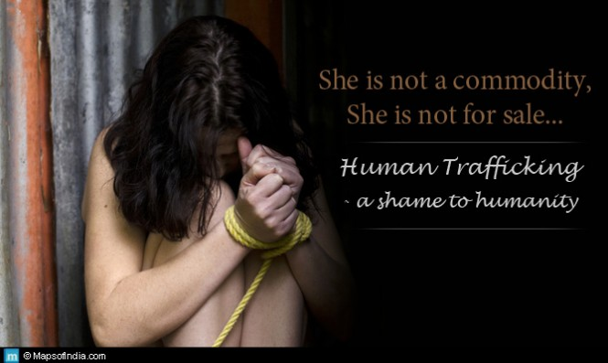
Ask and it will be given to you; seek and you will find; knock and the door will be opened to you. For everyone who asks receives; the one who seeks finds; and to the one who knocks, the door will be opened. Matthew 7:7-8

www.mapsofIndia.com

What is human Trafficking? It is the trade of humans, most commonly for the purpose of sexual slavery, forced labor or commercial sexual exploitation for the trafficker or others.

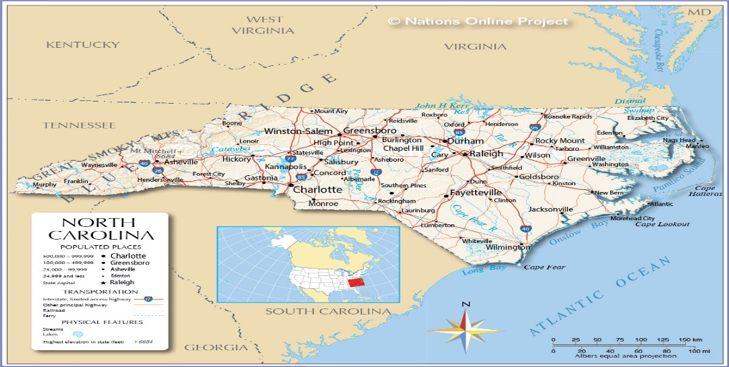

North Carolina is in the top 10 of states for Human Trafficking. Why is that?

We have major roads
- Plenty of hotels
- Truckstops
- Military Base
- We are a coastal state
- Immigrants

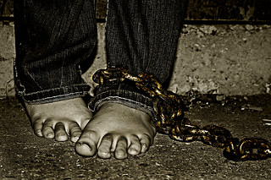

How can we help stop Human Trafficking?

- Learn the indicators of human trafficking so that you can help identify a potential trafficking victim. This can be done by participating in a human trafficking awareness training.
- If you believe that someone may be a victim of human trafficking contact your local law enforcement, call 911 or you can contact the 24 hour National Human Trafficking Resource Center line at 1-888-373-7888.
- Be a conscientious and informed consumer. It’s okay to ask who picked the vegetables or who made your clothes. You can also check out the Department of Labor’s List of Goods Produced by Child Labor or Forced Labor.
- Volunteer and support anti-trafficking efforts in your community
- Meet with and/or write your local, state and federal representatives to let them know you care about combating human trafficking, and ask what they are doing to address it.
- Host an awareness event to watch and discuss films about human trafficking.
- Organize a fundraiser and donate the proceeds to an anti-trafficking organization.
- Encourage your local schools to partner with students and include modern day slavery in their curricula. As a parent, teacher or school administrator, be aware of how traffickers target school-aged children.
- Be well informed. Set up a web alert to receive current human trafficking news. Become familiar with public awareness materials available from the Department of Health and Human Services or the Department of Homeland Security.
- Work with a local religious community or congregation to help stop human trafficking by supporting a victim service provider or spreading awareness of human trafficking.

Operation Underground Railroad

Tim Ballard is the CEO and Founder of Operation Underground Railroad or O.U.R. O.U.R. paves the way for permanent eradication of child sex trafficking through coordinated rescue and recovery planning. In the 3 years that they have been going, Tim and his highly trained team have rescued 641 victims and assisted in the arrest of more than 275 traffickers around the world.

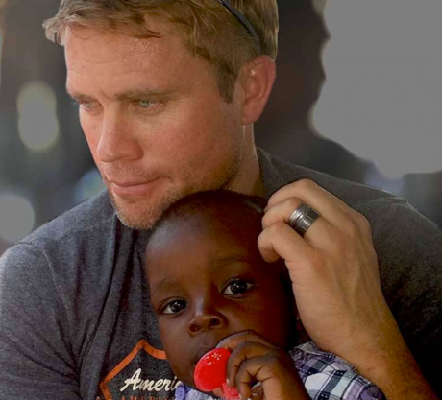
www.ourrescue.org
Do to others as you would have them do to you.
Luke 6:31

Training/Awareness Events for March

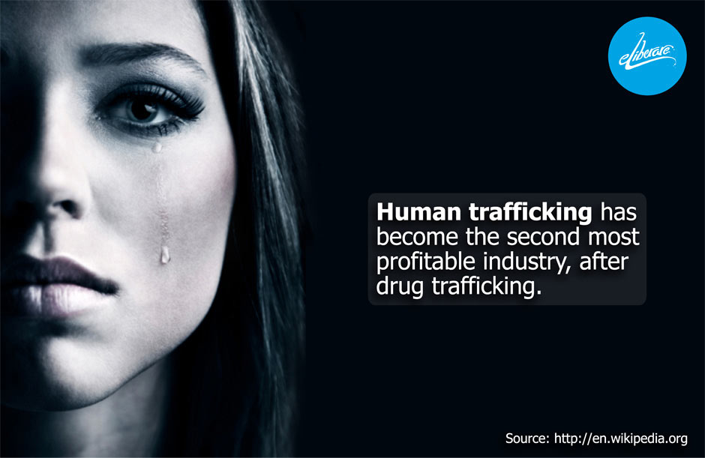
March 7, 2017

1:00 – 3:00

Hyde County Government Center
30 Oyster Creek Rd.
Swan Quarter, NC 27885
This will be a two hour training that will cover the definition of human trafficking, NC laws, where victims are likely to be found, how to recognize a victim, how to communicate with a victim and provide local resources.

Hosted by: Hyde County Hotline 252-925-2502. Please RSVP to Kathy Ballance at kbhydehotline@gmail.com or at the number listed above.

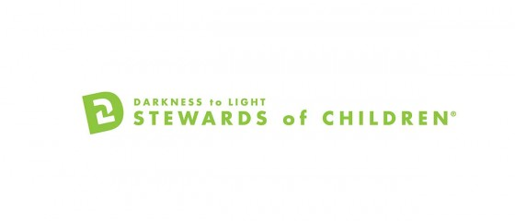
Stewards of Children:

Empowering people to prevent child sexual abuse.
Please join us for this important training March 16, 2017 at 1:00pm at the Hyde County Government Center.
Multipurpose Room
Please call or email Kathy Ballance if you would like to attend this training at: kbhydehotline@gmail.com or 252-925-2502.
Presented by: Kidsfirst, Inc. Child Abuse and Treatment Center
Hosted by: Hyde County Hotline

Websites References:
www.ourrescue.org
www.state.gov

One person can make a difference, and every person should try. – John Fitzgerald Kennedy

We love volunteers!
Please help and call
Hyde County Hotline at 252-925-2502.
Your Support Enables Hotline To Better Serve Victims and Survivors of Domestic Abuse
Please Consider
Donating to our Thrift Store
Financial Gifts
Asking about a Presentation
Your support of Hyde County Hotline enables us to continue serving victims and survivors in our communities.
Thank You!
Please call for more information at 252-925-2502

Hyde County Hotline offers support group for victims and survivors of domestic abuse and sexual victimization.
Domestic abuse support group is offered 1st and 3rd weeks of each month.
Sexual assault support group is offered 2nd and 4th weeks of each month.

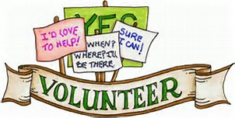

Thank you to the family Violence Prevention Services Program US DHHS, and NC Council for Women for financial support.

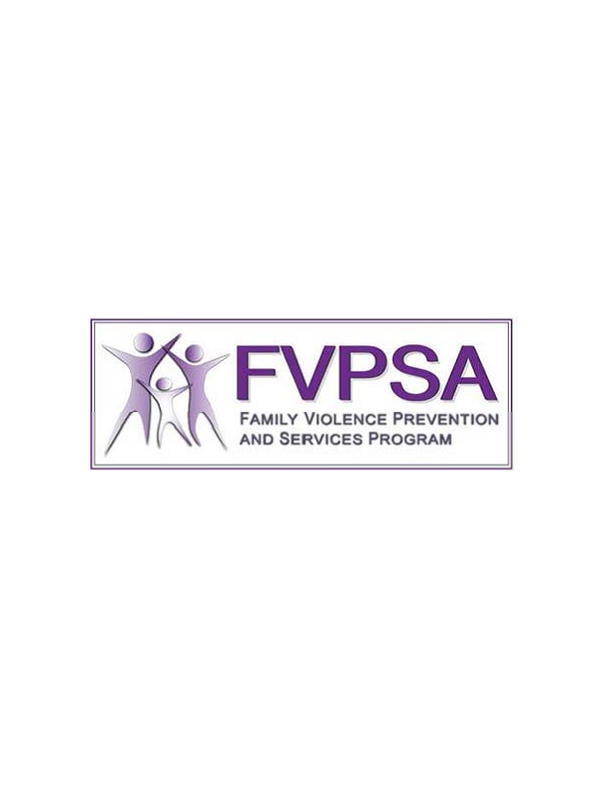

OUR MISSION: The purpose of Hyde County Hotline, Inc. is to work to eliminate domestic abuse and sexual victimization and provide safe shelter in Hyde County, North Carolina through the collaborative efforts of a compassionate community. We promote dignity, respect and safety at home resulting in safer communities.

HYDE COUNTY HOTLINE
24 HOUR CRISIS LINE
252-925-2500

